# Motivation

Music has always been an interesting market for any programming application: there are lots of researchses that try to create a predictive model that is able to guess some contest’s winner, or to understand which song somebody is listening to (e. g. Shazam).

The reason we chose, among all subjects, to work on a Machine Learning project that involved music is that we are really passionate about it and we wanted to experiment our new knowledge on something we are familiar with.

# Project’s Goal

Music, as already noted, has always been an interesting market for any programming application. But it’s not just that: though the retail compartment might be suffering a crysis, music continues **to expand** and reach new platforms, and **so do charts**: most of the modern charts, in fact, also enlist songs that are only available via Streaming Services such as Spotify.

For this project, we decided to build a classifier whose goal is to determine whether a certain song can enter the American Chart or not.

Why consider only the American charts and not any other country? There are two main reasons:

1. The US Market **offers more** **data** than any other country: for instance, we asked the [FIMI](https://www.fimi.it/) if it was possible to have the Italian chart as a .csv file and we were told that it wasn’t possible, due to the fact that the chart contains sensible data;
2. It was one of the first charts that started including, back in 2007, Streaming Services in their calculations.

The chart used as a reference will be the **Billboard Top 100**, which gets an update every week since 1936 and is considered one of the most famous all over the world.

## Setup

As for the project’s setup, this is what was used for developing our classifier:

* **Python 3.x;**
* **Visual Studio Code** as our Script Editor;
* **SciKit-Learn** for the ML algorithms;
* **Spotipy** as the wrapper for Spotify’s APIs;
* [This](https://data.world/typhon/billboard-hot-100-songs-from-1970-2017) dataset for the information regarding the Billboard. This is the most complete dataset available about it, since it collects data from the ‘70s up to 2018.

# Dataset overview

We will now have a brief description of the dataset and why we felt that the data proposed wasn’t enough.

## Dataset Description

The dataset, that from now on will also be called **Billboard’s Chart**, contains about 20104 rows. In the following screenshot, we present an insight of the available columns on it.

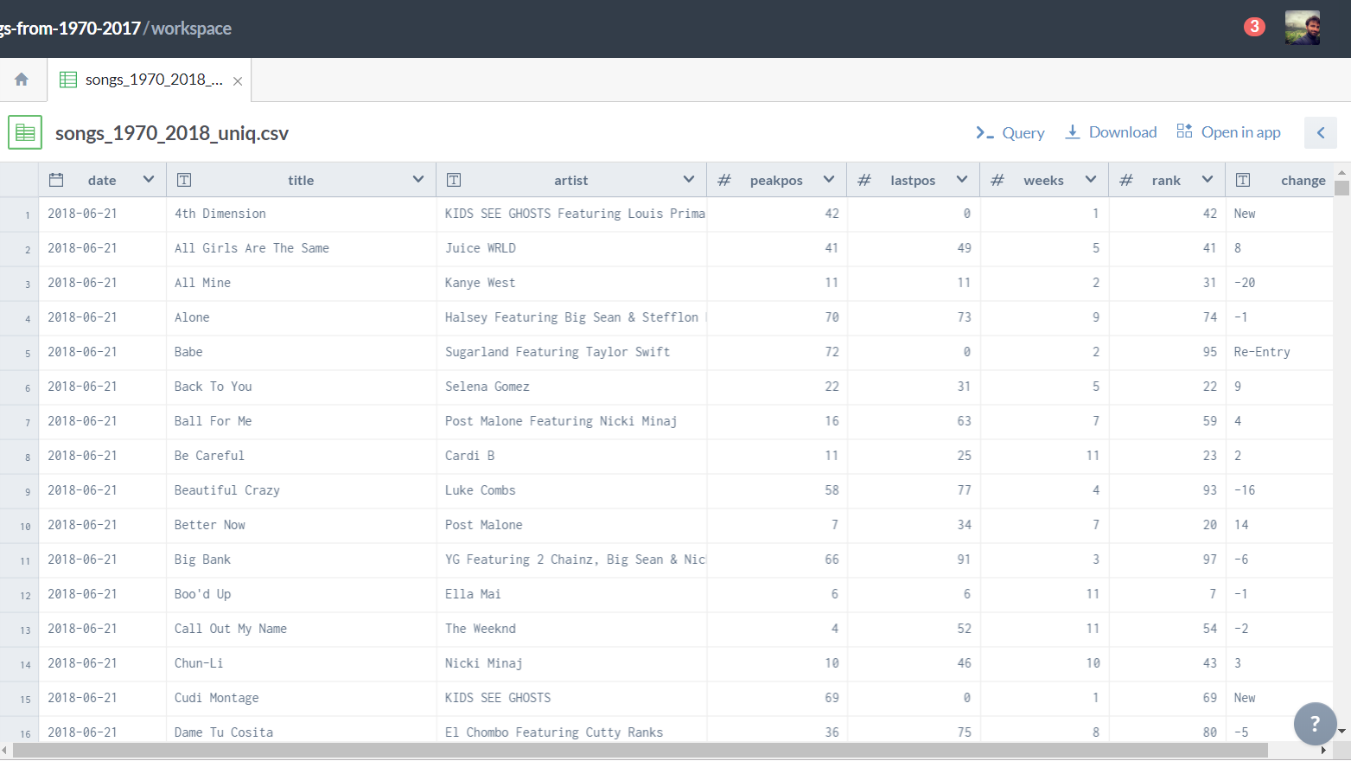

* **Date** column represents the date which the information is relative to (i. e. the date of that chart info)
* **Title** is the name of the track
* **Artist** is the name of the artist
* **Peakpos** represents the maximum position which that song ever reached in the chart
* **Lastpos** is the position in the chart the entry had in the preceding week
* **Weeks** describes how many weeks the song remained on the billboard
* **Rank**
* **Change** will tell the reader the change in rank in the chart of the song from the preceding week. For example, if the song is a new hit or a returning one there will respectively be “New” or “Re-Entry”. Numerical numbers will symbolize the position that the track gained/loss in the last week.

While the columns of this dataset give a lot of information, they are **not representative of** a song at its best, since this data only refers to the performance of a track in the chart. We felt that, in order to describe a song in a Machine Learning system, more accurate data was needed: something that could, somehow, describe the audio features of the hit.

For this reason, starting from the **Billboard’s Chart**, we decided **to create our own** dataset.

## Scraping from the web

In order to build our new dataset, though, first we need to define what will be our features for the new dataset.

As said before, we need something that can describe the audio features of the given track and **Spotify** might be of good help for this.

The Music Streaming giant, in fact, offers [an API](https://developer.spotify.com/documentation/web-api/reference/tracks/get-audio-features/) that, given the song’s ID (referring to the corresponding ID on their database), can return the description of the track with its musical features. The values that we are going to extract from this API are listed below:

|  |  |
| --- | --- |
| Feature | Description |
| Duration_ms | The duration of the track in milliseconds |
| Key | The estimated overall key of the track. Integers map to pitches using standard Pitch Class notation . E.g. 0 = C, 1 = C♯/D♭, 2 = D, and so on. If no key was detected, the value is -1. |
| Mode | Mode indicates the modality (major or minor) of a track, the type of scale from which its melodic content is derived. Major is represented by 1 and minor is 0 |
| Acousticness | A confidence measure from 0.0 to 1.0 of whether the track is acoustic. 1.0 represents high confidence the track is acoustic. |
| Danceability | Danceability describes how suitable a track is for dancing based on a combination of musical elements including tempo, rhythm stability, beat strengh, and overall regularity. A value of 0.0 is least danceable and 1.0 is most danceable. |
| Energy | Energy is a measure from 0.0 to 1.0 and represents a perceptual measure of intensity and activity. Typically, energetic tracks feel fast, loud and noisy. For example, death metal has high energy, while a Bach prelude scores low on the scale. Perceptual features contributing to this attribute include dynamic range, perceived loudness, timbre, onset rate, and general entropy. |
| Instrumentalness | Predicts whether a track contains no vocals. “Ooh” and “aah” sounds are treated as instrumental in this context. Rap or spoken word tracks are crearly “vocal”. The closer the instrumentalness value is to 1.0, the greater likelihood the track contains no vocal content. Values above 0.5 are intended to represent instrumental tracks, but confidence is higher as the values approaches to 1.0 |
| Liveness | Detects the presence of an audience in the recording. Higher liveness values represent an increased probability that the track was performed live. A value above 0.8 provides strong likelihood that the track is live. |
| Loudness | The overall loudness of a track in decibels (dB). Loudness values are averaged across the entire track and are useful for comparing relative loudness of tracks. Loudness is the quality of a sound that is the primary psychological correlate o f phsyical strength (amplitude). Values typical range between -60 and 0db. |
| Speechiness | Speechiness detects the presence of spoken words in a track. The more exclusively speech-like the recording (e.g. talk show, audio book, poetry), the closer to 1.0 the attribute value. Values above 0.66 describes tracks that are probably made entirely of spoken words. Values between 0.33 and 0.66 describe tracks that may contain both music and speech, either in sections or layered, including such cases as rap music. Values below 0.33 most likely represent music and other non-speech-like tracks. |

With that being said, we now present the code that was used for scraping this information from Spotify.

1. **from** spotipy.oauth2 **import** SpotifyClientCredentials
2. **import** json
3. **import** spotipy
4. **import** requests
5. **import** pandas
6. **import** time
7. **import** csv

10. **def** splitterFunction(artista):
11. **if** "featuring" **in** artista.lower():
12. toReturn = artista.lower().split("featuring")
13. **return** toReturn[0].strip()
14. **if** "feature" **in** artista.lower():
15. toReturn = artista.lower().split("feature")
16. **return** toReturn[0].strip()
17. **if** "&" **in** artista.lower():
18. toReturn = artista.lower().split("&")
19. **return** toReturn[0].strip()
20. **return** artista

23. artistNames = pandas.read_csv("billboard.csv", encoding = 'UTF-8')['artist']
24. trackNames = pandas.read_csv("billboard.csv", encoding = 'UTF-8')['name']
26. client_credentials_manager = SpotifyClientCredentials("75d944d4a2f64af3ada75b8d846451a8","399a7ee3bdc947b799148755314b4753")
27. spotify = spotipy.Spotify(client_credentials_manager=client_credentials_manager)
28. toSave = []
29. added = set()
30. contatore = 0
31. firstTime = True
33. **for** i **in** range(0, len(artistNames)):
34. **print**("Iterazione su " + str(artistNames[i]))
35. **if** contatore < 5000 **and** artistNames[i] **and** **not** trackNames[i] **in** added:
36. toFind = splitterFunction(artistNames[i])
37. results = spotify.search(q='artist:' + toFind +" track:" +trackNames[i], type='track')
38. time.sleep(2)
39. **if** results['tracks']['total'] == 0:
40. **print**("Non ho trovato nulla per " + str(artistNames[i]))
41. **continue**
42. idTraccia = results['tracks']['items'][0]['id']
43. analisiTraccia = spotify.audio_features(idTraccia)
44. contatore += 2
45. **if** None **in** analisiTraccia:
46. **print**("ANALISI NON DISPONIBILI PER " + str(trackNames[i])  + " DI " + str(artistNames[i]))
47. **continue**
48. toAppend = []
49. toAppend.append(trackNames[i])
50. toAppend.append(artistNames[i])
51. toAppend.append(1)
52. toAppend.append(analisiTraccia[0]['danceability'])
53. toAppend.append(analisiTraccia[0]['energy'])
54. toAppend.append(analisiTraccia[0]['loudness'])
55. toAppend.append(analisiTraccia[0]['speechiness'])
56. toAppend.append(analisiTraccia[0]['acousticness'])
57. toAppend.append(analisiTraccia[0]['instrumentalness'])
58. toAppend.append(analisiTraccia[0]['liveness'])
59. toAppend.append(analisiTraccia[0]['key'])
60. toAppend.append(analisiTraccia[0]['mode'])
61. toAppend.append(analisiTraccia[0]['duration_ms']/1000)
62. with open("datasetFINAL.csv", "a", encoding="UTF-8", newline='') as myfile:
63. wr = csv.writer(myfile)
64. **if** firstTime:
65. wr.writerow(("track","artist","billboarder","danceability","energy","loudness","speechiness","acousticness","instrumentalness","liveness","key","mode","duration"))
66. firstTime = False
67. **try**:
68. wr.writerows([toAppend])
69. **except** Exception:
70. **print**("Si è verificato un errore mentre cercavo di effettuare qualcosa sull'artista " + str(artistNames[i]) + " che ha fatto la traccia " + str(trackNames[i]))
71. myfile.close()
72. **print**("Aggiunto con successo " + str(artistNames[i]))
73. added.add(trackNames[i])
74. **if** contatore >= 5000:
75. time.sleep(180)
76. contatore = 0

For the dataset’s creation, we decided not to use pandas and use, instead, the built-in statement open() with resources.

After loading the two necessary columns from the **Billboard’s Chart**, we begin several iterations (as many as the number of tracks loaded) to question Spotify’s APIs in order to get all the informations we need. Lastly, we convert the **duration_ms** feature to seconds, and set the value presented in line 51 as 1. This is done because it will represent the test feature of the dataset (from there, the name “billboarder”).

There is still something missing, though: our fresh dataset is just full of **positive** values. If we train whatever Machine Learning algorithm with this dataset, it will be composed of just one class and it will make bad predictions.

For this reason, we searched for a new dataset that had to be “merged” with **datasetFinal**: during our research on Google, we found the link to [this](http://tsort.info/csv/top5000songs-2-8-0023.csv) resource which seemed what we needed, since it has 5000 rows.

# Choosing The Algorithm

Having worked in building the dataset and made some feature engineering, it is now time to decide which Machine Learning algorithm to use in order to build our classificator.

## Decision Tree

The first thing we consider is a Decision Tree. As one can imagine, this algorithm just builds a a tree that will make decisions.

1. data = pd.read_csv('datasetFINAL.csv', encoding='UTF-8')
2. features = data[["danceability", "energy", "loudness", "speechiness", "acousticness", "instrumentalness", "liveness",
3. "key", "mode", "duration"]]
4. target = data["billboarder"]
6. train_features, test_features, train_target, test_target = train_test_split(features, target)
8. clf = tree.DecisionTreeClassifier()
9. clf = clf.fit(train_features, train_target)
10. predictions = clf.predict(test_features)
12. **print**(confusion_matrix(test_target, predictions))
14. **print**(classification_report(test_target, predictions))

With the following code, we will make an evaluation of the data gathered so far and will try to see if it can meet our standards or not.

An output that the above code snippet can produce is something like this:

**Confusion Matrix**

[[ 437 579]

[ 670 3225]]

**Classification Report**

precision recall f1-score support

0 0.39 0.43 0.41 1016

1 0.85 0.83 0.84 3895

Is it good? Can a simple Decision Tree be enough? Well, not exactly: from the classification report, it is easy to see how the dataset still is inclined towards the positive values. Putting it in percents, about 75% of **datasetFinal** is made of positive values, which still seems to be too much for the algorithm.

What would happen if we try to select random values from the **datasetFinal,** in order to make it smaller?

1. positives = data[data["billboarder"] == 1]
2. negatives = data[data["billboarder"] == 0]
3. less_positives = positives.sample(len(negatives))
4. dataset = pd.concat([less_positives, negatives])
5. dataset.to_csv(‘datasetRidotto.csv’)

We let **pandas** do the job on choosing the elements. First, we create two variables that will hold the positive and negative part of the dataset; then, we tell pandas to choose an arbitrary length of the new dataset and, last but not least, we save it as **datasetRidotto.csv.**

Let’s see now what happens.

**Confusion Matrix**

[[740 270]

[292 759]]

**Classification Report**

precision recall f1-score support

0 0.72 0.73 0.72 1010

1 0.74 0.72 0.73 1051

This actually looks way better: with a dataset of approximately 8700 elements, we have a perfect and balanced situation, with a precision that is higher than 65% in both cases.